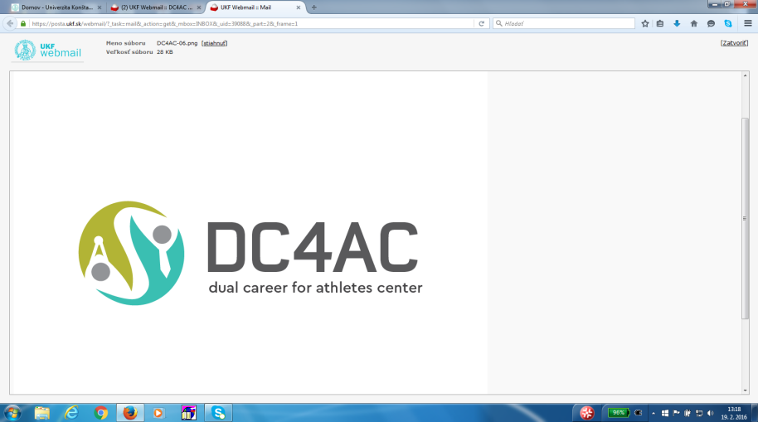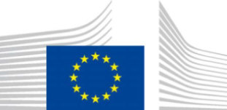

Handbook of Good Practice

in Dual Careers of Athletes

Slovak situation

**VERSION AS OF MARCH 2017**

**Elaborated by:** Jaromír Šimonek, Constantine the Philosopher University in Nitra, Slovakia

**CONTENTS**

1. Introduction
2. Main projects and initiatives concerning DC4AC in Slovakia
3. Main legislative regulations related to DC4AC in Slovakia
4. Agencies´ support
5. Web references
6. **INTRODUCTION**

The project “Regional Center For Dual Career” involves 8 European Countries for the European Guidelines for Dual Career evaluation and implementation in the European context. The proposal is co-financed by the Erasmus + Program for the athletes career management of the European Union. Dual career concerns the possibility for professional athletes to build a good educational path simultaneously with a sport career. Professional athletes, actually, face the difficult situation of conciliating intensive training and competition with education and work.

The project’s general aim is to develop an institutional organism, the regional center for dual career, being an excellence pole for dual career monitoring, evaluation and research. More specifically, the projects wants to deeply understand the athletes actual needs and expectations, taking into account the European Guidelines on Dual Career written by the European Union. On one hand, the project wants to explore the actual situation on dual career for pointing out good practices developed and implemented. On the other hand, the last proposal is to create concrete tools, such as workshop, campaigns, e-learning platforms in order to facilitate the dual career of athletes from a

practical point of view.

Here are the main steps of the project:

-Exploration of the actual Dual Career situation in the European Countries involved (Romania, Slovenia, Greece, Hungary, Bulgaria, Italy and Slovakia)

-In-depth analysis of the national law concerning Dual Career

-Dissemination campaign of the collected data

This Handbook tries to give a general overview of the actual Slovak situation as proposed in the first step.

The situation in the support of dual career of athletes is quite clear, but in fact unfavourable. There exist very little information about actions taken to support DC of athletes. There do not exist any federal projects, university projects, agencies projects, sport associations projects or ministerial projects. Despite the fact that the Slovak Ministry of Education, Science, Research and Sport received the recommendations from the European Commission about implementing the dual career guidelines, nothing has been done so far in the area of preparing legislative and regulative changes related to dual career of top athletes in sport.

In the next part of the report I present the exceptional activities in the subjective area in Slovakia, which are under progress.

1. **Main projects and initiatives concerning DC4AC in Slovakia**
2. **ERASMUS + SPORT PROJECTS / EU PROJECT**

Summary description of project

**Main objective**: to actively promote at regional level the principles, guidelines and best practices of Dual Career of Athletes; to coordinate the national efforts in Central and Est European participating countries with the aim to allow talented athletes and elite athletes to combine higher education studies or work and high level sport.

Objective No. 1: Raising awareness about the needs of dual careers in professional and non-professional sports

Objective No. 2: Active lobby and good practices dissemination

Objective No. 3: Continuous learning test programme

1. **ATHLETE CAREER PROGRAMME (ACP)**

Project’s previous name was Master 2000, it is an European project of International Olympic Committee in collaboration with Adecco, one of the most important Company of placement in Slovakia and in the World. In Italy it should be managed by National Olympic Committee, but there has been reported very feeble interest in it on the side of athletes and their coaches. It’s dedicated to national/international athletes/former athletes that gain results in Olympic/Paralympic Games, World/European or National level, or involved in Teams of maximum leagues (League A or B) of each sport.

The requirements for access are:

* To be unemployed

- Having the middle school educational title

- To be strongly motivated toward work.

The project aim is to include athletes unemployed in the job market. They

offer a 4 steps program concerning:

* orientation to work
* career transition workshop
* vocational training
* internship.

1. **Main legislative regulations related to DC4AC in Slovakia**

**Act on Sport No. 354/2016 Coll**., which has **come into force on January 1, 2016** legally stipulates the following chapters:

1. sport competition,
2. subjects in sport,
3. legal relationships upon performing, organizing, managing, administering and supporting and developing sport,
4. solving disputes in sport,
5. competences of public administration bodies in sport,
6. measures against negative phenomena in sport (doping, hooliganism, xenophoby, racism, etc.).

Sport clubs and unions have to guarantee:

„**Contract on talented athlete sport preparation**“ 3-year-long contract + professional contract

**THE ACT ON SPORT -** a new type of school – „**SECONDARY SPORT SCHOOL“**

- offers **secondary professional education** and would include only pupils with the talent for sport.

This section of the **Act on Sport** will come into force **on January 1, 2019.**

**SECONDARY SPORT SCHOOL** would provide:

a) **comprehensive secondary education** (e.g servicing and maintenance of sport facilities,

b) **secondary general education** (the current secondary grammar school – study programme 7902 J 77 – sport),

c) **complete secondary professional education** (e.g. sport management, sport organizer, sport expert, etc.).

This type of secondary school would be **focusing merely on:**

* Pupils with sport talent – all classes would be sport classes
* More than one specialization in a sport class
* **Certification** from the particular sport union on the level of performance of the sportsmen would be required for enrollment

**Compulsory requirements on sport schools:**

* Regeneration (quality and regularness)
* Testing of sport performance (regularness+ ranks)
* Theoretical preparation
* Psychological support
* Tutoring

**Universities/sports faculties:**

**- prepare elite athletes for post-athletic career (**coach, sport manager, PE teacher or fitness manager).

**Specific of universities´ arrangements include**:

* flexibility of timetable,
* adapted curriculum,
* e-learning programmes,
* distant education,
* supplementary tutoring,
* individual tempo of learning,
* the use of facilities and sport services,
* other supporting services....

**Potential jobs of athletes - they can work for:**

* the government,
* public institutions,
* the armed forces,
* the police,
* the border police,
* the forestry sector,
* the customs service, ........

**The new Act on Sport stipulates explicitely the definitions of terms in sport, among them: professional athlete, elite athlete, talented athlete, etc**., thus providing legislative framework for tax levying and starting business of athletes.

1. **AGENCIES SUPPORT**

Since 2008, the Slovak Olympic Committee cooperates with the personal company **Adecco Slovakia** on the project of the IOC Athlete Career Program focusing on the support of elite athletes (olympians, representantives) when transiting from professional sport career into the civil life. This programme has been realized since 2005.

In general, so far there is a very feeble interest of sport federations and athletes in the professional seminar “Career programme for athletes” offered by Adecco.

**Web references:**

<https://www.slov-lex.sk/static/pdf/2016/354/ZZ_2016_354_20170101.pdf>

(**Act on Sport No. 354/2016 Coll**. - Zákon o športe č.354/2016 z.z.)

[**http://www.noveaspi.sk/products/lawText/1/85613/1/2**](http://www.noveaspi.sk/products/lawText/1/85613/1/2)

**(Decree No. 51/2016 Coll.** As of December 2015, on health care of elite athletes and talented athletes)

<https://www.minedu.sk/data/files/5274_zakon-o-prispevku.pdf>

**Act No. 112 as of May 14, 2015** on financial contribution to sport representative of Slovakia (amendment to the Act No. 461/2003 Coll. on social insurance of athletes.

# <http://www.mtf.stuba.sk/docs//doc/legislativa/2014/Zakon_131-2002_o_vysokych_skolach_s_ucinnostou_1.1.2014.pdf>

# Act on higher education No. 131/2002 Coll.